final submission:
1. submit source code, external libraries, dependencies
2. submit user docs - how to install, set up, deploy, how to use ALL features (include screenshots for every step)
3. push everything to github and include link in submission
4. project report - overall dev process, ALL user stories - how they are implemented, managed, and tracked, any difficulties or missing features + reasons why + how we tried to overcome

user docs:
prereqs:
1. Java 21+
2. Git
3. NPM
4. Python 3.9+
5. Node.js 16+

setup and deployment:
1. clone the repo from github and cd into the folder.

- git clone https://github.com/joelshrestha-dev/Software-Eng-App.git
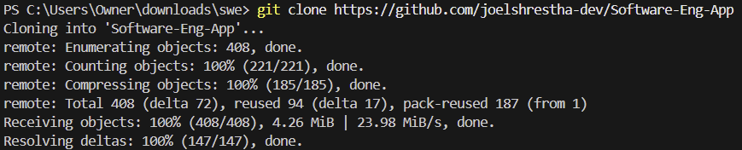

- cd software-eng-app

2. cd calendar-backend and run:
- .\mvnw.cmd spring-boot:run
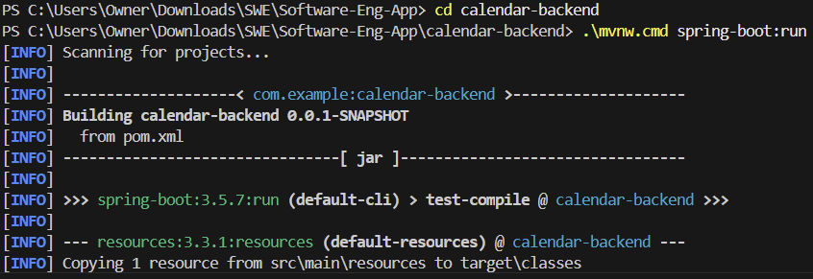

3. cd ai_backend and run:
- pip install uvicorn
- pip install "fastapi[standard]" pdfplumber python-dotenv openai
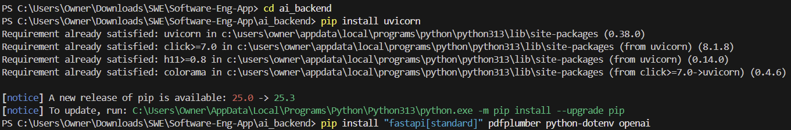
- uvicorn chatbot:app --reload
- OR
- python -m uvicorn chatbot:app --reload
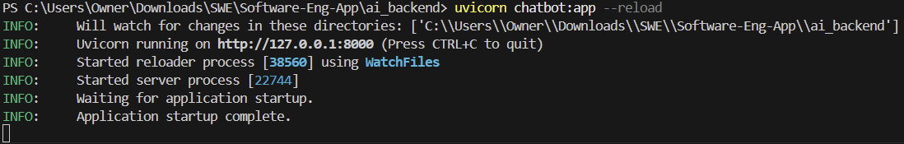

4. cd website and run:
- npm install
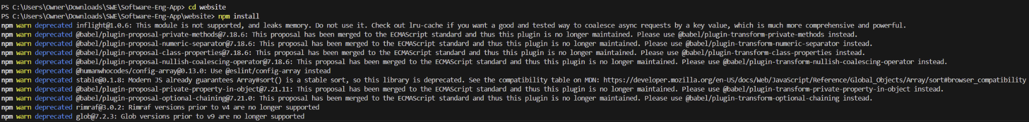
- npm start
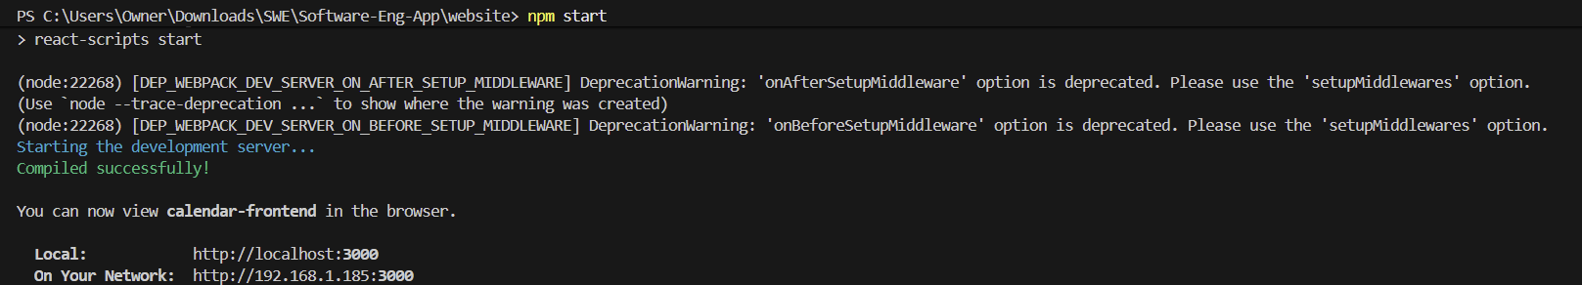

It should automatically open a browser window to the application but in case it doesn't:
- open browser and go to http://localhost:3000/

- you should see the app:

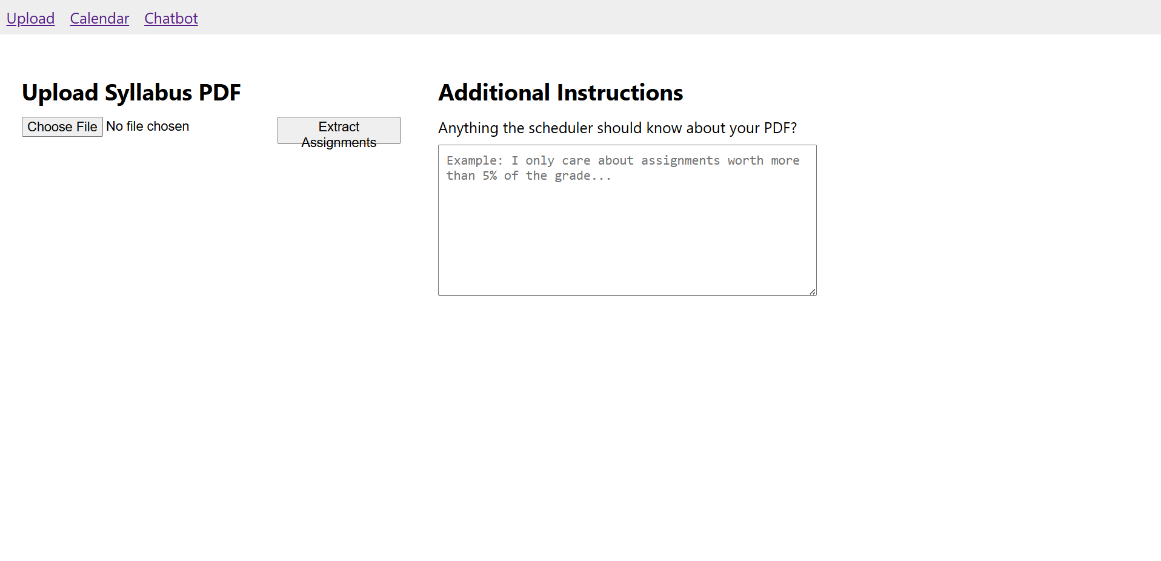

how to use features:
1. upload syllabus in pdf format
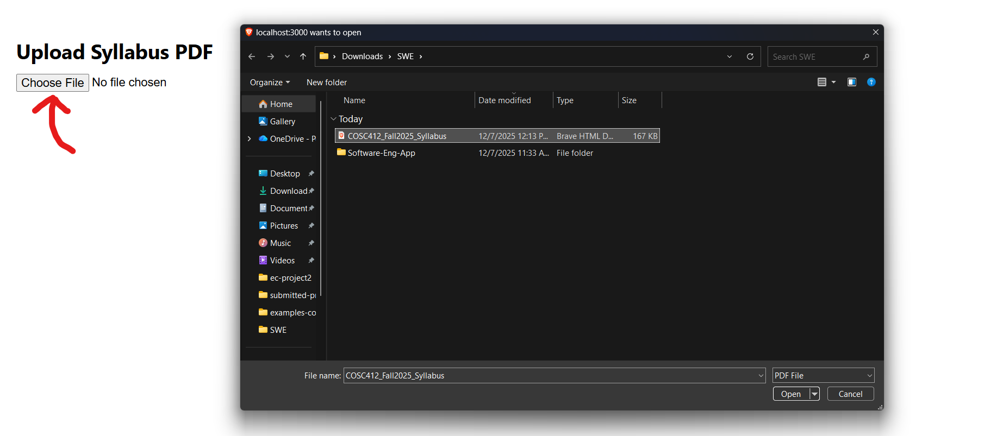

2. after the file is uploaded, you may add additional instructions if you wish:
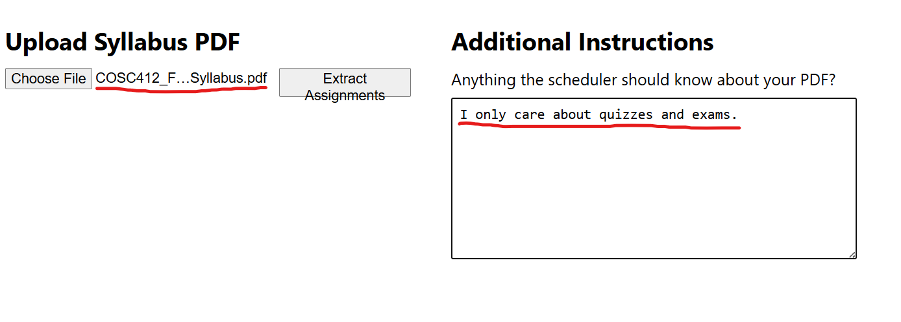
3. click extract assignments and the app will generate a list of your upcoming assignments using the power of ai

